
Building Code Consulting

Project Address:
1812 H PL SE, Washington D.C.

Construction Code Verified:
2017 DCMR 12A (2015 International Building Code)
2017 DCMR 12E (2015 International Mechanical Code)
2017 DCMR 12F (2015 International Plumbing Code)
2017 DCMR 12C (2014 National Electric Code)
2017 DCMR 12H (2015 International Fire Code)
2017 DCMR 12I (2013 ANSI/ASHRAE 90.1)
2017 DCMR 12K (2012 Green Construction Code)
2017 DCMR 12I (2015 International Energy Conservation Code)
2013 NFPA 72
2013 NFPA 13
2013 NFPA 14

I hereby certify that the project has been designed according the construction code above:
Fire Protection | 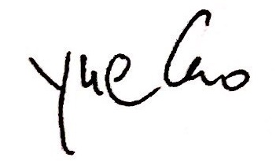 | 11/25/2025
Sprinkler System |  | 11/25/2025

